GOVERNMENT POLYTECHNIC COLLEGE

MUTTOM- THODUPUZHA



Report on

BANK MANAGEMENT SYSTEM

Submitted By

ALOK KUMAR DEBNATH

FOURTH SEMESTER COMPUTER ENGINEERING

Register No. 19138128

DEPARTMENT OF COMPUTER ENGINEERING

2020-2021

GOVERNMENT POLYTECHNIC COLLEGE

MUTTOM- THODUPUZHA



DEPARTMENT OF COMPUTER ENGINEERING

## CERTIFICATE

This is to certify that the project entitled “BANK MANAGEMENT SYSTEM” is a Bona fide record of work done by ALOK KUMAR DEBNATH, Reg. No: 19138128 of 4th semester Computer Engineering for the partial fulfilment of requirements for the award of “DIPLOMA IN COMPUTER ENGINEERING” under the Department of Technical Education, Government of Kerala during the academic year 2020-2021.

HEAD OF THE DEPARTMENT GUIDE IN CHARGE

EXTERNAL EXAMINER INTERNAL EXAMINER

### ACKNOWLEDGEMENT

I wish to extend heartfelt thanks to everyone who helped in providing basic knowledge for completing this project. I would like to give the first honour to MODERN INTERNET which gave the wisdom and knowledge to complete the mini project.

I wish to extend my sincere gratitude to Mrs. GEETHA DEVI, Principal and Mrs. SAJINA K PAULOSE, Head of the Department of Computer Engineering for giving me the opportunity to complete this seminar successfully.

I wish to extend my sincere thanks to my seminar guide Mr. JOSE JAMES for his valuable support and guidance. I thank him for his timely suggestion and constant encouragement that boosted up my morale and led to the accomplishment of this seminar.

ALOK KUMAR DEBNATH

### INDEX

Content Page No:

INTRODUCTION 4

ABSTRACT 5

SYSTEM ANALYSIS AND DESIGN 6

FUNCTION OVERVIEW 7

DATA DICTIONARY 8

SOURCE CODE 9

SCREENSHOTS 28

CONCLUSION 33

REFERENCE 33

# INTRODUCTION

This project BANK MANAGEMENT SYSTEM is aimed to develop an app aimed for bank employees for the ease of managing Account holder details and doing online transactions on behalf of Account holder. The UI and ease of usage was the top priority, even if that was the top priority the functionality was not ignored and there are all the features I can currently think of. The database connectivity is planned using the SQL connection methodology. This system is developed on Java platform and supported by a MySQL database to store bank and user specific details.

# ABSTRACT

This project BANK MANAGEMENT SYSTEM is aimed to develop an app aimed for bank employees for the ease of managing Account holder details and doing online transactions on behalf of Account holder. The UI and ease of usage was the top priority, even if that was the top priority the functionality was not ignored and there are all the features I can currently think of. The database connectivity is planned using the SQL connection methodology. The application takes care of different modules and their associated reports, which are produced as per the applicable strategies and standards that are put forward by the administrative staff. The entire project has been developed keeping in view of the distributed client server computing technology.

# SYSTEM ANALYSIS AND DESIGN

Requirement analysis is the process of identifying the system requirements through the observations of the existing system, discussion with the potential user’s procedures, task analysis etc. Requirement’s analysis results in the specifications of software operational characteristics indicates software’s interface with other elements and establishes constraints that software must need. A project requirements analysis removes all ambiguities and inconsistencies from the initial user perception of the problem.

### HARDWARE AND SOFTWARE REQUIREMENTS

SOFTWARE REQUIREMENTS

OPERATING SYSTEM: WINDOWS/UBUNTU

LANGUAGE : JAVA

FONTEND : JAVA

BACKEND : MYSQL

DEVELOPMENT TOOL: Net Beans ide 8.2 HARDWARE REQUIREMENTS

PROCESSOR: INTEL PENTIUM CORE 8

MAIN MEMORY: 1GB RAM

SECONDARY MEMORY 500 GB HARDISK

VIRTUAL DISPLAY UNIT RESOLUTION OF 1024X76

APPLICATION & USER

There is only one type of user for this application, who has all privileges to make changes to the settings of this application and on the data.

# FUNCTION OVERVIEW

#### REGISTER / LOGIN

Employees who have permission to manage user data and transactions, have to register by providing their name, email, branch, password. If user is already registered then they can login by providing the email and password. These details will be stored in database.

#### ACCOUNT DETAILS

Employee or Admin can manage basic account holder details from here. Every single change will be logged in the system for security and safety reasons. Here new account data can be added, edited or even be deleted.

#### TRANSACTIONS

Transactions such as Withdraw/Deposit or Fund transfer between accounts can be done. The process is as simple as possible so that any new employee can also get accustomed to the whole process very easily and effortlessly.

# DATA DICTIONARY

REGISTRATION DETAILS DATABASE

|  |  |
| --- | --- |
| Field name | Data type |
| name | varchar |
| email | varchar |
| branch | varchar |
| Password | varchar |

LOGIN DETAILS

|  |  |
| --- | --- |
| Field name | Data type |
| email | varchar |
| password | varchar |

CUSTOMER DETAILS

|  |  |
| --- | --- |
| Field name | Data type |
| Account_no | varchar |
| name | varchar |
| balance | varchar |

LOG

|  |  |
| --- | --- |
| Field name | Data type |
| log | varchar |

# SOURCE CODE

#### Fetch data from database to table

public void fetch()

{

try{

Class.forName("com.mysql.jdbc.Driver");

Connection con=DriverManager.getConnection("jdbc:mysql://localhost:3306/db_internetbanking","root","");

String sql="select * from tbl_customer_details";

System.out.println(sql);

PreparedStatement pst = con.prepareStatement(sql);

ResultSet rs = pst.executeQuery();

DefaultTableModel dl=(DefaultTableModel)jTable_account2.getModel();

dl.setRowCount(0);

while(rs.next())

{

Vector v2=new Vector();

v2.add(rs.getString("id"));

v2.add(rs.getString("account_no"));

v2.add(rs.getString("name"));

v2.add(rs.getString("balance"));

dl.addRow(v2);

}

}

catch(Exception e)

{

System.out.println(e);

}

}

#### Insert new account holder data into database

String ac_no=jTextField_acc_no_account2.getText();

System.out.println(ac_no);

String name=jTextField_name_account2.getText();

System.out.println(name);

try{

Class.forName("com.mysql.jdbc.Driver");

Connection con=DriverManager.getConnection("jdbc:mysql://localhost:3306/db_internetbanking","root","");

String sql = "insert into tbl_customer_details(account_no,name,balance)values('"+ac_no+"','"+name+"','0')";

System.out.println(sql);

Statement stmt=con.createStatement();

int rs=stmt.executeUpdate(sql);

System.out.println(rs);

if(rs==1)

{

JOptionPane.showMessageDialog(this, "Added Successfully");

//log

String log_statement = "A/c added where A/c number = " + ac_no + " and name = " + name;

String sql_log = "insert into tbl_log_account(log,user)values('"+log_statement+"','employee')";

System.out.println(sql_log);

Statement stmt_log=con.createStatement();

int rs_log=stmt_log.executeUpdate(sql_log);

System.out.println(rs_log);

//log end

fetch();

clear();

}

}

catch(Exception e)

{

System.out.println(e);

}

#### Update Account holder data

DefaultTableModel dl=(DefaultTableModel)jTable_account2.getModel();

int index=jTable_account2.getSelectedRow();

int id=Integer.parseInt(dl.getValueAt(index,0).toString());

String ac_no=jTextField_acc_no_account2.getText();

System.out.println(ac_no);

String name=jTextField_name_account2.getText();

System.out.println(name);

try{

Class.forName("com.mysql.jdbc.Driver");

Connection con=DriverManager.getConnection("jdbc:mysql://localhost:3306/db_internetbanking","root","");

//log

String updatelog = "select * from tbl_customer_details where id='"+id+"'";

System.out.println(updatelog);

PreparedStatement pst2 = con.prepareStatement(updatelog);

ResultSet logg;

logg = pst2.executeQuery();

System.out.println(logg);

if(logg.next())

{

String account = logg.getString("account_no");

String customername = logg.getString("name");

System.out.println(account);

System.out.println(customername);

System.out.println(!ac_no.equals(account));

System.out.println(!name.equals(customername));

if(!ac_no.equals(account))

{

String log_statement = "A/c number changed from " + account + " to " + ac_no + " where id = " + id;

String sql_log = "insert into tbl_log_account(log,user)values('"+log_statement+"','employee')";

System.out.println(sql_log);

Statement stmt_log=con.createStatement();

int rs_log=stmt_log.executeUpdate(sql_log);

System.out.println(rs_log);

}

if(!name.equals(customername))

{

String log_statement = "Name changed from " + customername + " to " + name + " where A/c number = " +ac_no+ " and id = " + id;

String sql_log = "insert into tbl_log_account(log,user)values('"+log_statement+"','employee')";

System.out.println(sql_log);

Statement stmt_log=con.createStatement();

int rs_log=stmt_log.executeUpdate(sql_log);

System.out.println(rs_log);

}

}

//log end

String sql = "update tbl_customer_details set account_no='"+ac_no+"',name='"+name+"' where id='"+id+"'";

System.out.println(sql);

Statement stmt=con.createStatement();

int rs=stmt.executeUpdate(sql);

System.out.println(rs);

if(rs==1)

{

JOptionPane.showMessageDialog(this, "Updated Successfully");

fetch();

clear();

}

}

catch(Exception e)

{

System.out.println(e);

}

#### Delete account holder data

DefaultTableModel dl=(DefaultTableModel)jTable_account2.getModel();

int index=jTable_account2.getSelectedRow();

int id=Integer.parseInt(dl.getValueAt(index,0).toString());

//for log

String ac_no=jTextField_acc_no_account2.getText();

System.out.println(ac_no);

String name=jTextField_name_account2.getText();

System.out.println(name);

//

int dialogResult = JOptionPane.showConfirmDialog(null,"Do you want to delete","warning",JOptionPane.YES_NO_OPTION);

if(dialogResult==JOptionPane.YES_OPTION)

{

try{

Class.forName("com.mysql.jdbc.Driver");

Connection con=DriverManager.getConnection("jdbc:mysql://localhost:3306/db_internetbanking","root","");

String sql="delete from tbl_customer_details where id = '"+id+"'";

System.out.println(sql);

Statement stmt=con.createStatement();

int rs=stmt.executeUpdate(sql);

System.out.println(rs);

if(rs==1){

JOptionPane.showMessageDialog(this, "Deleted Successfully");

//log

String log_statement = "A/c deleted where A/c number = " + ac_no + " and id = " + id;

String sql_log = "insert into tbl_log_account(log,user)values('"+log_statement+"','employee')";

System.out.println(sql_log);

Statement stmt_log=con.createStatement();

int rs_log=stmt_log.executeUpdate(sql_log);

System.out.println(rs_log);

//log end

fetch();

clear();

}

}

catch(Exception e)

{

System.out.println(e);

}

}

#### Deposit money

String account_no=jTextField_accno.getText();

System.out.println(account_no);

String amount=jTextField_amount.getText();

System.out.println(amount);

if(amount.equals(""))

{

jLabel_error_message.setText("Please enter an amount");

//show jpanel message

timerDown2.start();

}

try{

Class.forName("com.mysql.jdbc.Driver");

Connection con=DriverManager.getConnection("jdbc:mysql://localhost:3306/db_internetbanking","root","");

String sql = "select balance from tbl_customer_details where account_no='"+account_no+"'";

System.out.println(sql);

PreparedStatement pst = con.prepareStatement(sql);

ResultSet rs = pst.executeQuery();

System.out.println(rs);

if(rs.next())

{

String am = rs.getString("balance");

Integer f1=Integer.parseInt(amount);

Integer f2=Integer.parseInt(am);

Integer f3=f2+f1;

String s=String.valueOf(f3);

System.out.println(s);

String sq = "update tbl_customer_details set balance='"+s+"' where account_no='"+account_no+"'";

System.out.println(sq);

Statement stmt=con.createStatement();

int rs2=stmt.executeUpdate(sq);

System.out.println(rs2);

if(rs2==1)

{

//log

String log = "Rs. "+amount+" deposited to A/c "+account_no;

String sql_log = "insert into tbl_log(log)values('"+log+"')";

System.out.println(sql_log);

Statement stmt_log=con.createStatement();

int rs_log=stmt_log.executeUpdate(sql_log);

System.out.println(rs_log);

//////

JOptionPane.showMessageDialog(this, "Deposit Successfully");

clear2();

// hide the jpanel message

timerUp.start();

// hide the jpanel message

timerUp2.start();

}

}else

{

//for data validation

if(account_no.equals(""))

{

jLabel_error_message.setText("Please enter an account number");

//show jpanel message

timerDown2.start();

}/*else if(amount.equals(""))

{

jLabel_error_message.setText("Please enter an amount");

//show jpanel message

timerDown2.start();

}*/else

{

jLabel_error_message.setText("Incorrect account number");

//show jpanel message

timerDown2.start();

}

//////////////////////

}

}

catch(Exception e)

{

System.out.println(e);

}

#### Withdraw money

String account_no=jTextField_accno.getText();

System.out.println(account_no);

String amount=jTextField_amount.getText();

int a = Integer.parseInt(amount);

System.out.println(amount);

if(amount.equals(""))

{

jLabel_error_message.setText("Please enter an amount");

//show jpanel message

timerDown2.start();

}

try{

Class.forName("com.mysql.jdbc.Driver");

Connection con=DriverManager.getConnection("jdbc:mysql://localhost:3306/db_internetbanking","root","");

String sql = "select balance from tbl_customer_details where account_no='"+account_no+"'";

System.out.println(sql);

PreparedStatement pst = con.prepareStatement(sql);

ResultSet rs = pst.executeQuery();

System.out.println(rs);

if(rs.next())

{

String am = rs.getString("balance");

int b = Integer.parseInt(am);

if(a < b){

Integer f1=Integer.parseInt(amount);

Integer f2=Integer.parseInt(am);

Integer f3=f2-f1;

String s=String.valueOf(f3);

System.out.println(s);

String sq = "update tbl_customer_details set balance='"+s+"' where account_no='"+account_no+"'";

System.out.println(sq);

Statement stmt=con.createStatement();

int rs2=stmt.executeUpdate(sq);

System.out.println(rs2);

if(rs2==1)

{

//log

String log = "Rs. "+amount+" withdrawn from A/c "+account_no;

String sql_log = "insert into tbl_log(log)values('"+log+"')";

System.out.println(sql_log);

Statement stmt_log=con.createStatement();

int rs_log=stmt_log.executeUpdate(sql_log);

System.out.println(rs_log);

//////

JOptionPane.showMessageDialog(this, "Withdrawal Successfully");

clear2();

// hide the jpanel message

timerUp.start();

// hide the jpanel message

timerUp2.start();

}

}else{

//JOptionPane.showMessageDialog(this, "Amount exceeds available balance");

jLabel_error_message.setText("Amount exceeds maximum withdrawal limit for this account");

//show jpanel message

timerDown2.start();

}

}else

{

//for data validation

if(account_no.equals(""))

{

jLabel_error_message.setText("Please enter an account number");

//show jpanel message

timerDown2.start();

}/*else if(amount.equals(""))

{

jLabel_error_message.setText("Please enter an amount");

//show jpanel message

timerDown2.start();

}*/else

{

jLabel_error_message.setText("Incorrect account number");

//show jpanel message

timerDown2.start();

}

//////////////////////

}

}

catch(Exception e)

{

System.out.println(e);

}

#### Fund transfer

String from=jTextField_from.getText();

System.out.println(from);

String to=jTextField_to.getText();

System.out.println(to);

String amount=jTextField_amount2.getText();

int amou = Integer.parseInt(amount);

System.out.println(amount);

try{

Class.forName("com.mysql.jdbc.Driver");

Connection con=DriverManager.getConnection("jdbc:mysql://localhost:3306/db_internetbanking","root","");

String sql = "select * from tbl_customer_details where account_no='"+from+"'";

String sql2 = "select * from tbl_customer_details where account_no='"+to+"'";

System.out.println(sql);

PreparedStatement pst = con.prepareStatement(sql);

ResultSet rs = pst.executeQuery();

System.out.println(rs);

System.out.println(sql2);

PreparedStatement pst2 = con.prepareStatement(sql2);

ResultSet rs2 = pst2.executeQuery();

System.out.println(rs2);

if(rs.next() && rs2.next())// && amount.equals("")

{

String bal1 = rs.getString("balance");

int bala = Integer.parseInt(bal1);

if(amou < bala){

Integer f1=Integer.parseInt(bal1);

Integer f2=Integer.parseInt(amount);

Integer f3=f1-f2;

String s=String.valueOf(f3);

System.out.println(s);

String sq = "update tbl_customer_details set balance='"+s+"' where account_no='"+from+"'";

System.out.println(sq);

Statement stmt=con.createStatement();

int rs3=stmt.executeUpdate(sq);

System.out.println(rs3);

//////////////////////////////////////

String bal2 = rs2.getString("balance");

Integer g1=Integer.parseInt(bal2);

Integer g2=Integer.parseInt(amount);

Integer a=g1+g2;

String s2=String.valueOf(a);

System.out.println(s2);

String sq2 = "update tbl_customer_details set balance='"+s2+"' where account_no='"+to+"'";

System.out.println(sq2);

Statement stmt2=con.createStatement();

int rs4=stmt2.executeUpdate(sq2);

System.out.println(rs4);

/////////////////////////////////////

//log

String log = "Rs. "+amount+" transfered from A/c "+from+" to A/c "+to;

String sql_log = "insert into tbl_log(log)values('"+log+"')";

System.out.println(sql_log);

Statement stmt_log=con.createStatement();

int rs_log=stmt_log.executeUpdate(sql_log);

System.out.println(rs_log);

JOptionPane.showMessageDialog(this, "Fund Transfer Successfully");

// hide the jpanel message

timerUp3_transfer.start();

clear3();

}else{

//JOptionPane.showMessageDialog(this, "Amount exceeds available balance");

jLabel_error_message2.setText("Insufficient balance");

//show jpanel message

timerDown3_transfer.start();

}

}else {

jLabel_error_message2.setText("Please enter Correct account number");

//show jpanel message

timerDown3_transfer.start();

}

}

catch(Exception e)

{

System.out.println(e);

}

//for data validation

if(from.equals("") && to.equals(""))

{

jLabel_error_message2.setText("Please enter account number");

//show jpanel message

timerDown3_transfer.start();

}else if(from.equals(""))

{

jLabel_error_message2.setText("Please enter Sender account number");

//show jpanel message

timerDown3_transfer.start();

}else if(to.equals(""))

{

jLabel_error_message2.setText("Please enter Payee account number");

//show jpanel message

timerDown3_transfer.start();

}else if(amount.equals(""))

{

jLabel_error_message2.setText("Please enter an amount to transfer");

//show jpanel message

timerDown3_transfer.start();

}

#### Login page

// TODO add your handling code here:

String email=jTextField_email.getText().trim();

System.out.println(email);

String password = String.valueOf(jPasswordField1.getPassword()).trim();

System.out.println(password);

if(email.equals(""))

{

jLabel_error_message.setText("Please enter your email");

}else if(password.equals(""))

{

jLabel_error_message.setText("Please enter your password");

}else

{

jLabel_error_message.setText("Incorrect email or password");

}

try {

Class.forName("com.mysql.jdbc.Driver");

Connection con=DriverManager.getConnection("jdbc:mysql://localhost:3306/db_internetbanking","root","");

String sql="select * from tbl_reg where email = '"+email+"' && password = '"+password+"' ";

System.out.println(sql);

Statement stmt=con.createStatement();

ResultSet rs=stmt.executeQuery(sql);

//System.out.println(rs);

if(rs.next()){

JOptionPane.showMessageDialog(null, "Login Successful");

this.dispose();

dashboard d=new dashboard();

d.setVisible(true);

}

} catch (Exception e) {

System.out.println("Error "+e);

}

//show jpanel message

timerDown.start();

}

#### Registration page

String name=jTextField_name.getText();

System.out.println(name);

String email=jTextField_email.getText();

System.out.println(email);

String branch=jTextField_branch.getText();

System.out.println(branch);

String password=jPasswordField1.getText();

System.out.println(password);

//Giving database connection below

try {

Class.forName("com.mysql.jdbc.Driver");

Connection con=DriverManager.getConnection("jdbc:mysql://localhost:3306/db_internetbanking","root","");

String sql="insert into tbl_reg(name,email,branch,password,position) values('"+name+"','"+email+"','"+branch+"','"+password+"','')";

System.out.println(sql);

Statement stmt=con.createStatement();

int rs=stmt.executeUpdate(sql);

System.out.println(rs);

if(rs==1){

JOptionPane.showMessageDialog(null, "Registration Successful");

login l=new login();

l.setVisible(true);

dispose();

}

} catch (Exception e) {

System.out.println(e);

}

# SCREENSHOTS

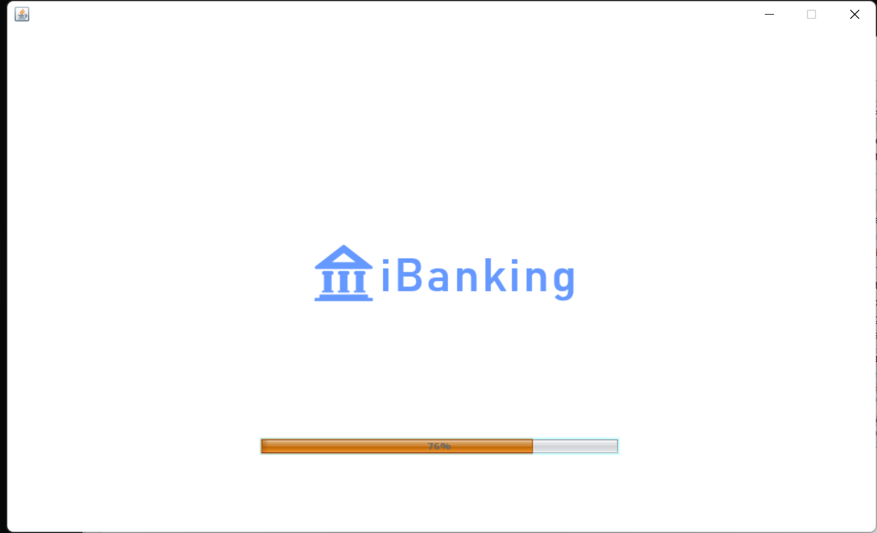

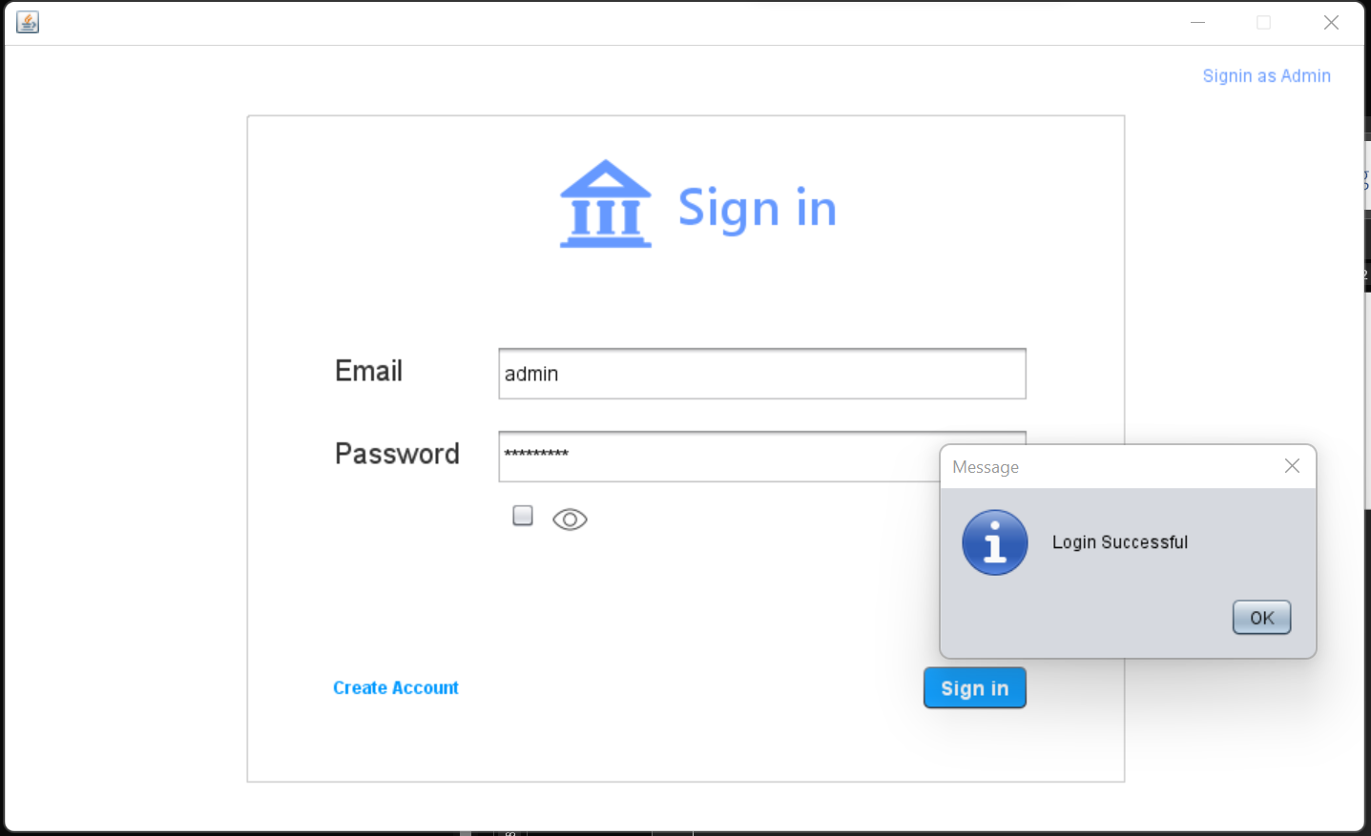

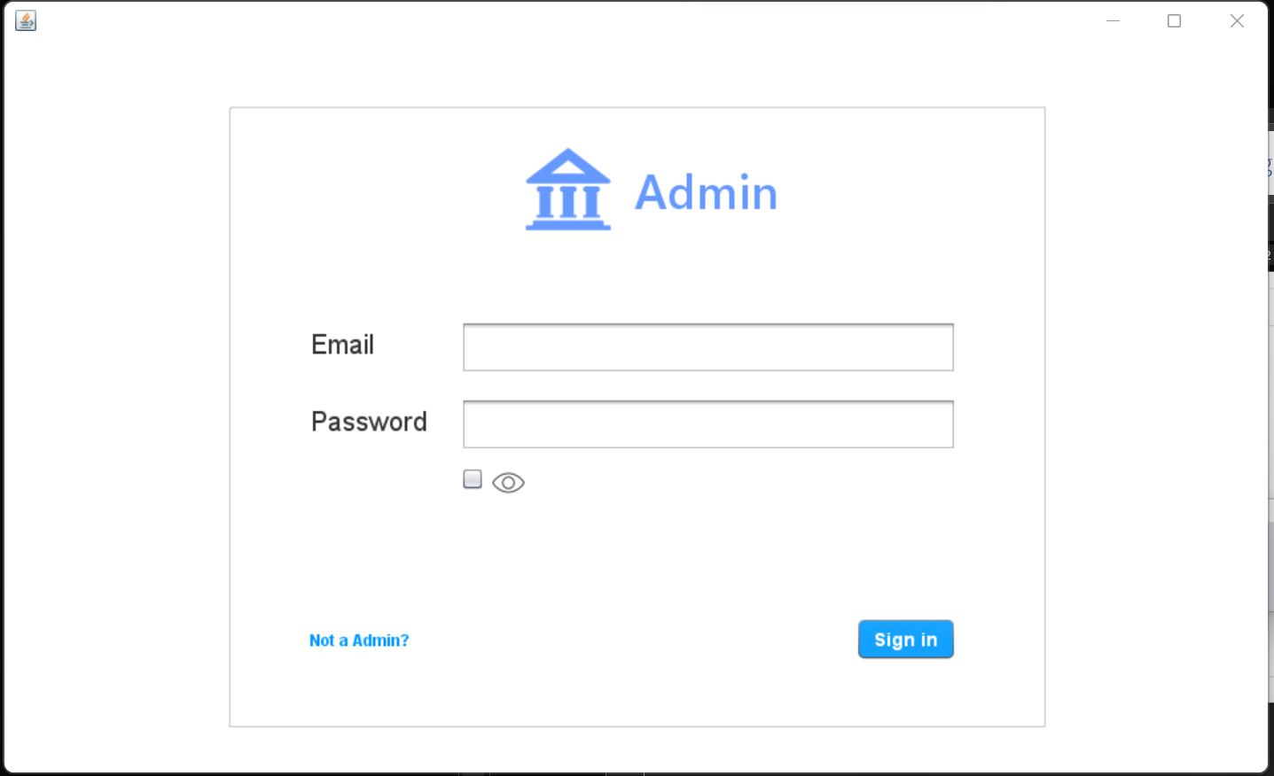

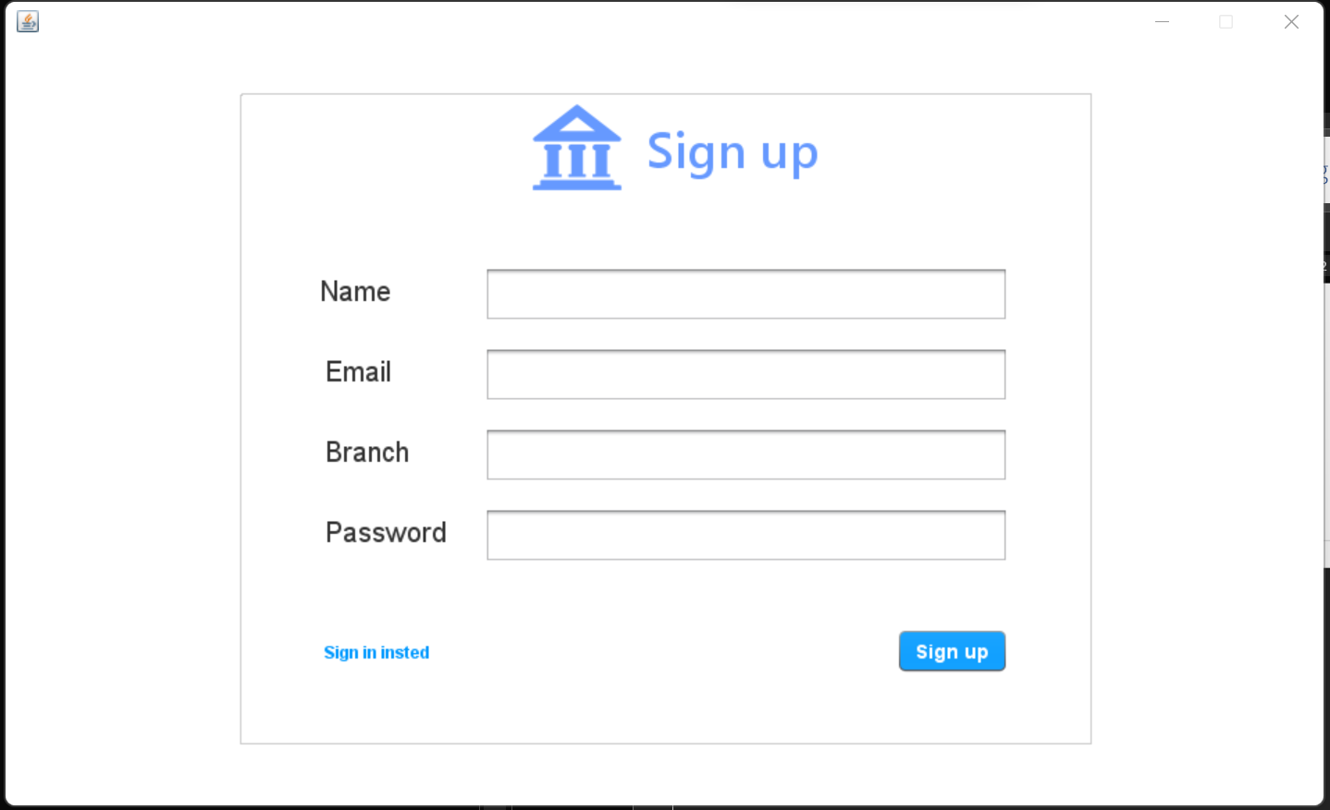

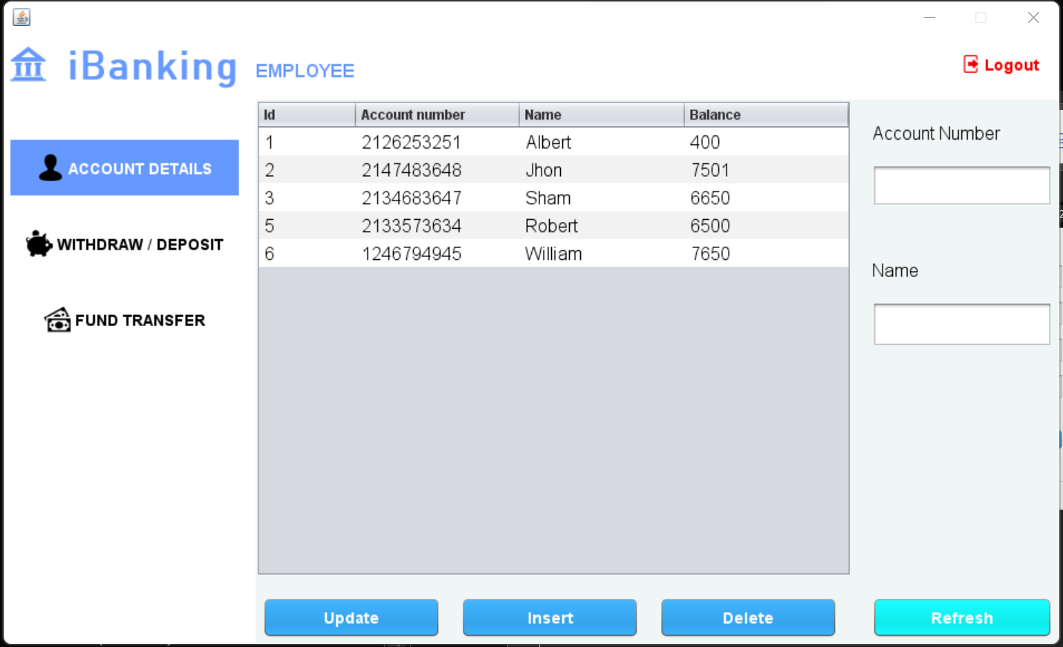

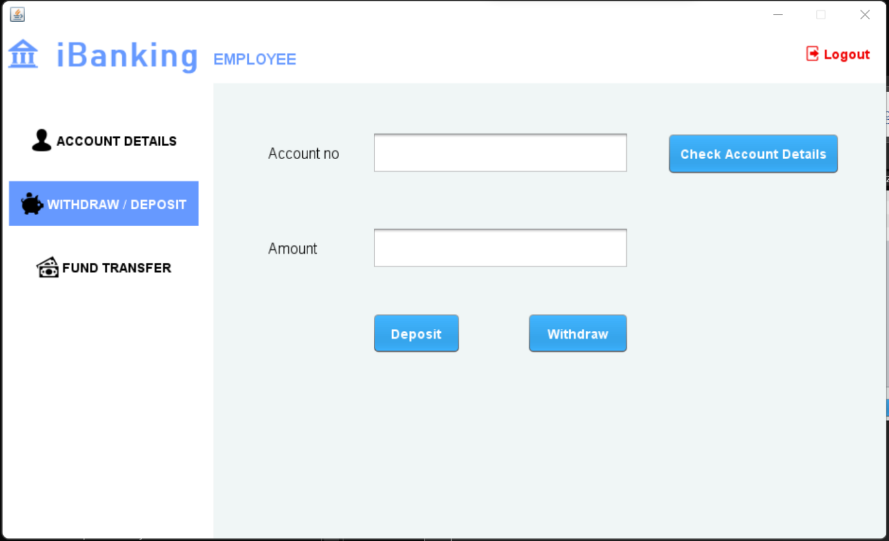

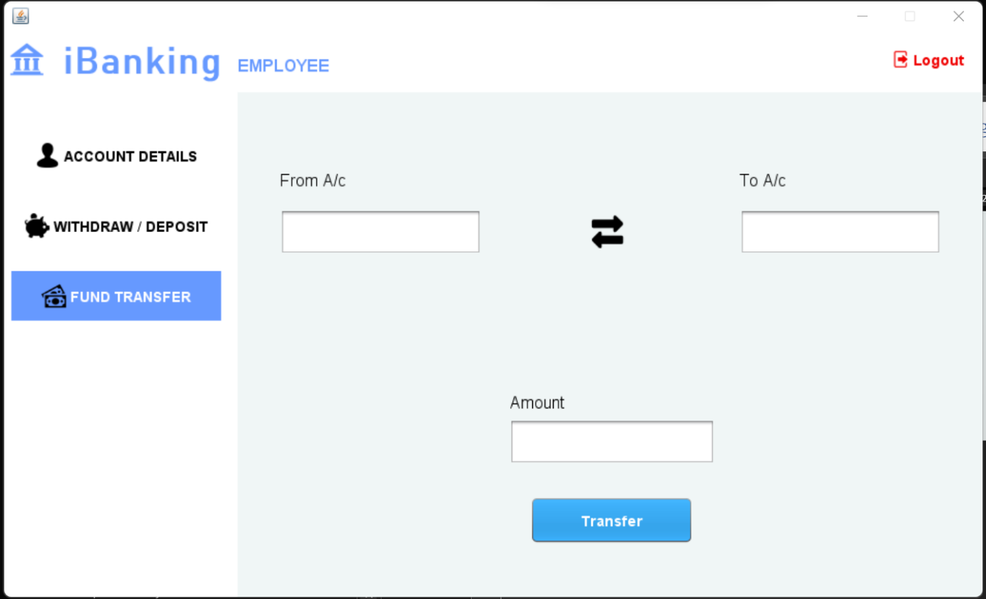

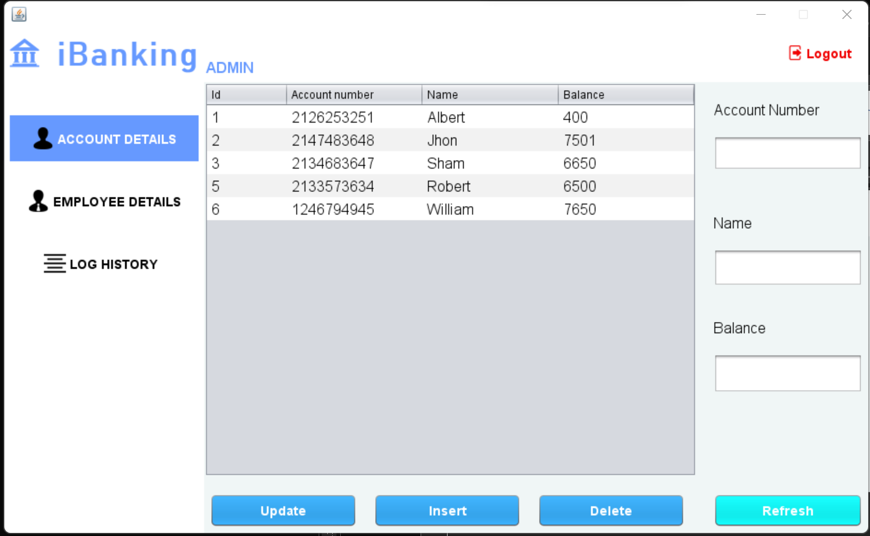

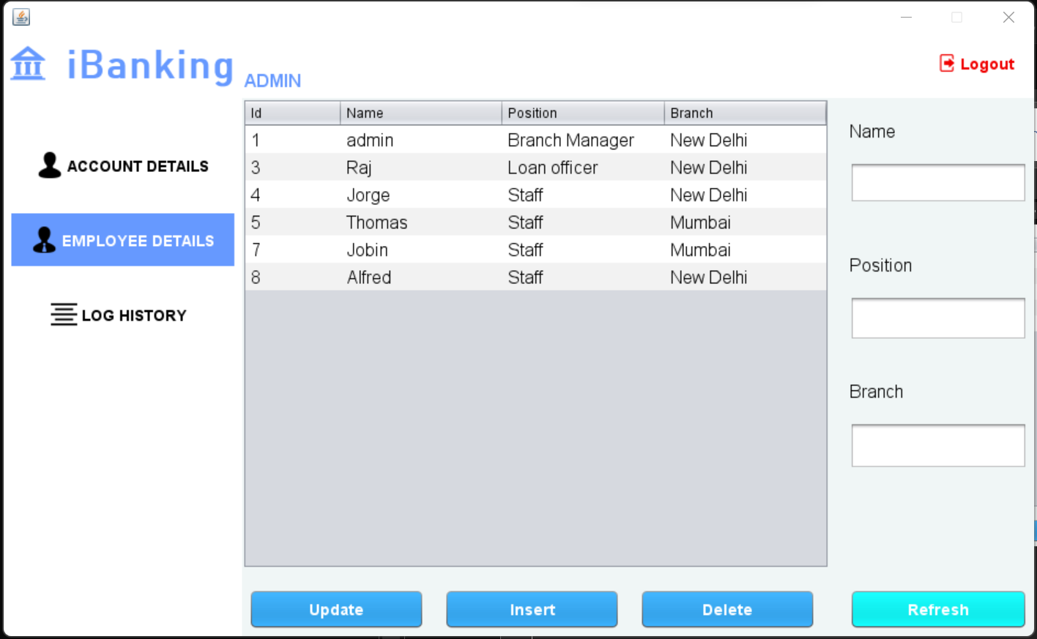

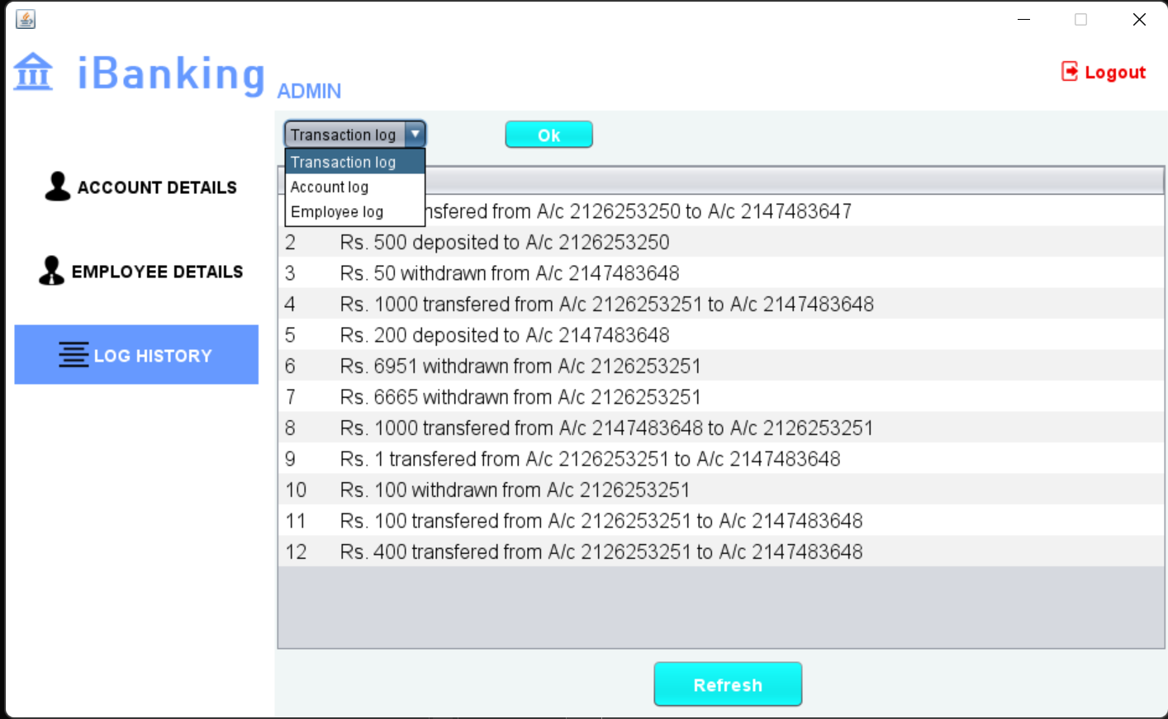

# CONCLUSION

This project is developed for creating a software that can be use by employees and admin within a bank. The purpose of this application is to ease the process used at bank and to simply and make the UI up to the modern standards.

# REFERENCE

For solving common errors: <https://stackoverflow.com/>

My UI inspiration: <https://www.codewithc.com/online-bank-management-system-project-java/>

Some UI interactions: <https://www.youtube.com/watch?v=eSM_YkWeS7k>